Welcome to Office Suite 6930 Series
Phone Features & Voicemail Set up

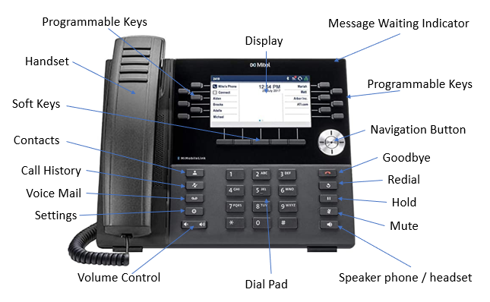

Use the Navigation keys to move left or right between pages

LOGIN | ACTIVATE
Note: Your phone should be logged in, but if it isn’t or is Logged Out, log in.
- To log into your phone press, Activate/Login option.
- Enter your Extension Number.
- Enter the pin for the phone. (See System Admin) The extension pin can be reset in Admin portal (See System Admin)

TO ANSWER A CALL
- Lift the handset or press the Speaker Phone function button. 
Note: The clear panel area at the top of your handset is your Visual Ring Indication. When your handset rings, the area will flash red. When on an active call, the area lights solid red.

Ending A CALL
- Place the handset back in its cradle, press the End Call softkey, or press this hard key. 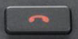

EXTERNAL CALL
1. Lift the handset or press the Speaker Phone function button.
2. Dial 9 +10-digit number for local, and 9 +1+10- digit number for long distance/toll free.

INTERNAL CALL – 3 options
- Dial the user’s extension (activates your speaker phone automatically).
- If you have a button programmed on your phone for a user, simply press the button.
- Press the ‘Contact’ function button, scroll to find the User and follow the prompts in the display.
The phone will ring until answered or until it forwards to voicemail.

INTERCOM CALL
- Press the Intercom function button.
- Dial the extension number and press the CALL softkey OR press the User’s Monitor Key
Note: This will immediately activate the speaker phone of the person you are calling.
*Can’t intercom to a cordless phone

PAGE (to page over all the telephones)
- Press the PAGE programmed button
The speakers on all idle phones are opened and you can now page to all idle phones.

TO PLACE A CALL ON HOLD
- Press the Hold function button  to place the current call on hold.
The call appearance button will blink green.
While on an active call, you can answer another incoming call by pressing the flashing call appearance that you would like to answer.

PARK (Park Button programmed on desk phone)
To Park a Call:
- While on an active call, press an open programmed Park button (ex: Park 1, Park 2, etc)
- The caller is now parked.

To Retrieve a Parked Call:
- From Any desk phone with programmed Park keys – Press the “Park/Retrieve” button the caller was parked on
(Ex: Call parked on Park 1, Park 2, etc.)

PARK (Park Button not programmed on desk phone)
- While on an active call, press the Park/Retrieve Softkey. The system will state the Park number that has been selected or assigned. (Remember this number – this number will be used to retrieve the parked call)
- The caller is now parked.

To Retrieve a Parked Call:
- Press “Park/Retrieve” softkey and enter the noted park slot to retrieve your call.

MUTE
- While on an active call, press the Mute Function button. 
The Mute button lights solid red while muted.
- To unmute, press the Mute function button again and the red light is removed.

VOLUME CONTROL

- Press the volume control keys . while the phone is ringing to adjust the ringer volume.
- Pressing these keys during an active call adjusts the volume of the audio device being used (handset, headset, or speaker).

TRANSFER A CALL

- Blind Transfer User does not talk to the transfer recipient prior to transferring a call.
  - While on an active call, press the Transfer function button.
  - Dial the transfer recipient’s extension number (or 9 + external number)
  - Press the Transfer Softkey button.

- Attended Transfer: User talks with the transfer recipient prior to transferring a call.
  - While on an active call, press the Transfer function button.

  - Dial the transfer recipient’s extension number (or 9 + external number)
  - Wait for the user to answer then, announce the call.
**If you receive voicemail and want to go back to the caller, press QUIT softkey and then select the line to return to the caller.
  - Press the Transfer Softkey

- To VM: User sends the call immediately to the assigned user’s voice mailbox.
  - While on an active call, press the Transfer function button.
  - Press the To VM Softkey
  - Dial the Transfer recipient’s extension number.

CONFERENCE CALL
Connect up to four parties (including the originator) on one conference call.

While on an active call, press the Softkey Conference.
- Dial the second party.
    - External recipient’s number, 9 + 10 digits Local calls, or 9 +1 +10 digits Long Distance/Toll Free.
    - Or Internal Number.
- When the party answers, press the Softkey option in the display for ‘Conference’. 3-Way call is now active.
Note: If you wish to add a fourth party to your conference, proceed with the below steps.
  - Dial your next party.
  - Press the Softkey option in the display for ‘Conference’. All 4 parties are now connected.

Note: You can press the Softkey option in the display for ‘Leave’ to exit a 3-Way conference leaving the other two parties connected (display will reflect call was transferred). The ‘Leave’ option only appears with a 3-Way Conference. You cannot ‘Leave’ a 4-Way Conference call without disconnecting the entire conference.

ADDING A CONTACT
- Press the Contacts button
- Select Personal (Personal is editable / Corporate is not)
- Personal stores up to 50 personal speed dial numbers
- Corporate lists all the extensions on your phone system
2. Press the Softkey option for ‘Add New’.
3. Enter First Name and Number using the navigator cluster and the number dial pad
**make sure to enter 9 + the 10-digit number (local). or 9 + 1 + 10 -digit number (long distance/toll free) ***Pressing the star key twice will add a space between a 2-word name
4. Press the Save softkey

PERSONAL VOICEMAIL SETUP & FEATURES

SET UP VOICEMAIL:
- Press the Messages key 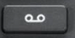 on your phone. You will hear, “Please enter your passcode. If you are not calling from your phone press *”
- Enter your passcode followed by the # sign. The default PIN is: SEE ADMIN
- Follow the prompts to set up your mailbox and change your passcode.

VOICEMAIL MENU
1 Listen to your Messages 2 Send a message 9 User Options

PERSONAL VMAIL NOTIFICATION:
When new messages have arrived, the ‘Messages’ function button will illuminate red.

TO RETRIEVE A PERSONAL VMAIL MESSAGE:
- Press the Messages key , “Please enter your passcode. If you are not calling from your phone press *”
- Enter your passcode followed by the # sign.

LISTENING SHORTCUTS:
While Listening to Messages, you can perform the following actions:
1 Replay 2 Save 3 Delete 4 To return the call 5 Forward 6 Message Information 0 Help
Note: Messages are automatically saved unless deleted

TO ACCESS YOUR PERSONAL VOICEMAIL REMOTELY:
- If you have a direct dial number, call your direct dial phone number to reach your voicemail.
- During your voicemail greeting press * and follow the prompt to enter your passcode followed by #.

MESSAGE OPTIONS AFTER INITIAL SETUP:
1. Press the Messages key, “Please enter your passcode. If you are not calling from your phone press *(star)”
2. Enter your passcode followed by the # sign.
3. Press 9
4. You can then select from the following options:

Press 1 to review or change your NAME or GREETING.
Press 2 to review/change your personal(primary) greeting or Press 4 to review/change your alternate greeting.
Press 2 to change your password.
Press 3 to change your message options.
Press 4 to change your Call Answer options (determine what greeting callers hear or prevent callers from leaving a message after greeting is played).
Press * to return to the main menu.



More Information & Training Videos:
https://communities.windstreamenterprise.com/OfficeSuite-UC/discussion/7723784/how-to-operate-your-officesuite-uc-phoneshttps://windstream.jiveon.com/

